CMPE 277

Smartphone Application Development

Lab 2



Submitted to –

Prof. Hungwen Li

on

02/28/2019

by –

Varun Jain

013719108

varun.jain@sjsu.edu

Snapshots

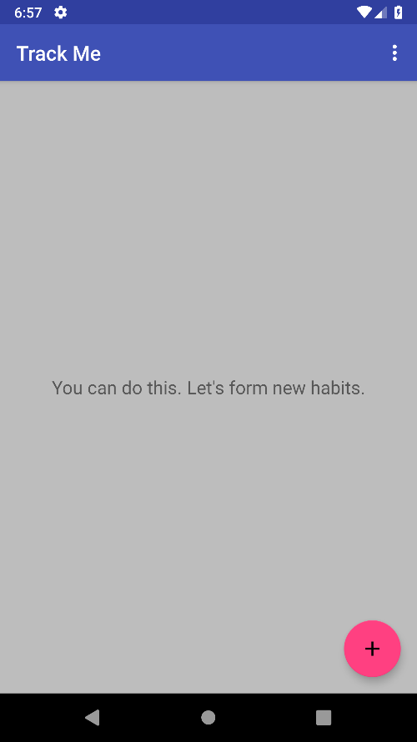

Add a new habit with action bar

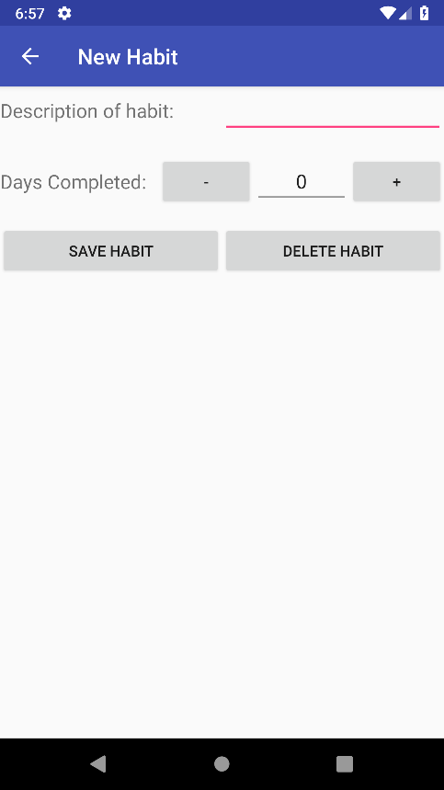

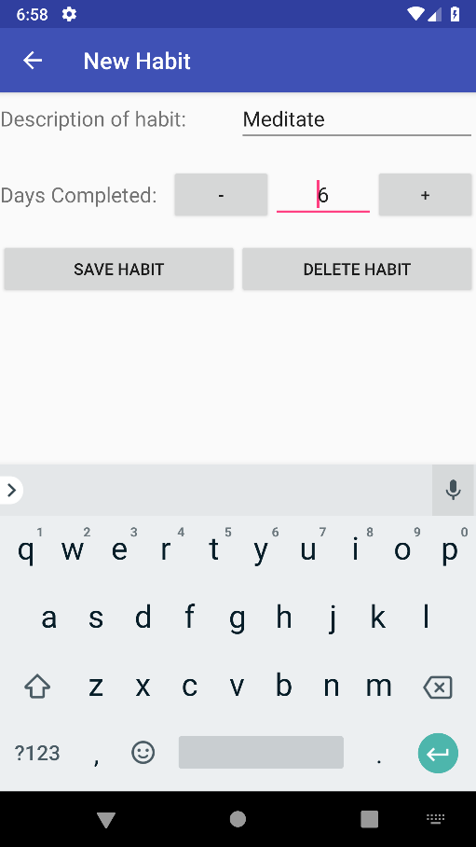

Habit on Main Activity

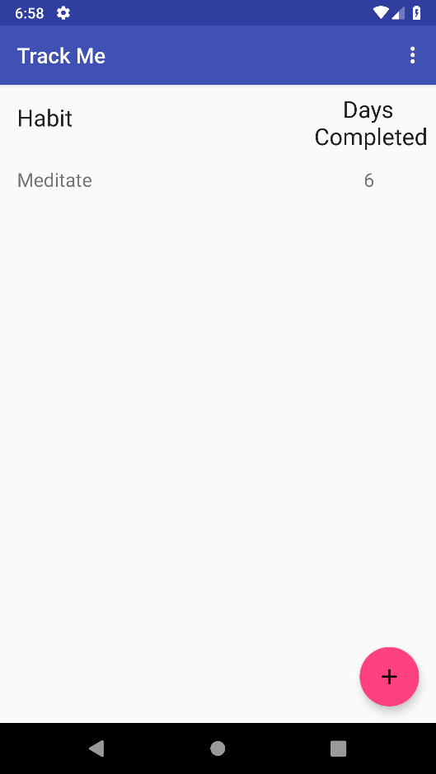

Multople Actiivity

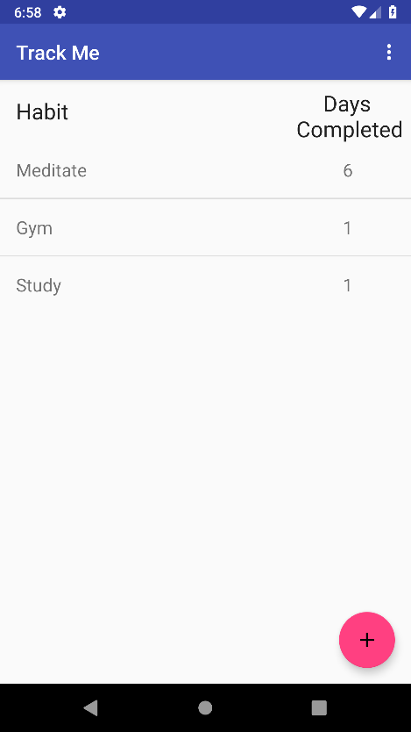

Delete All Button

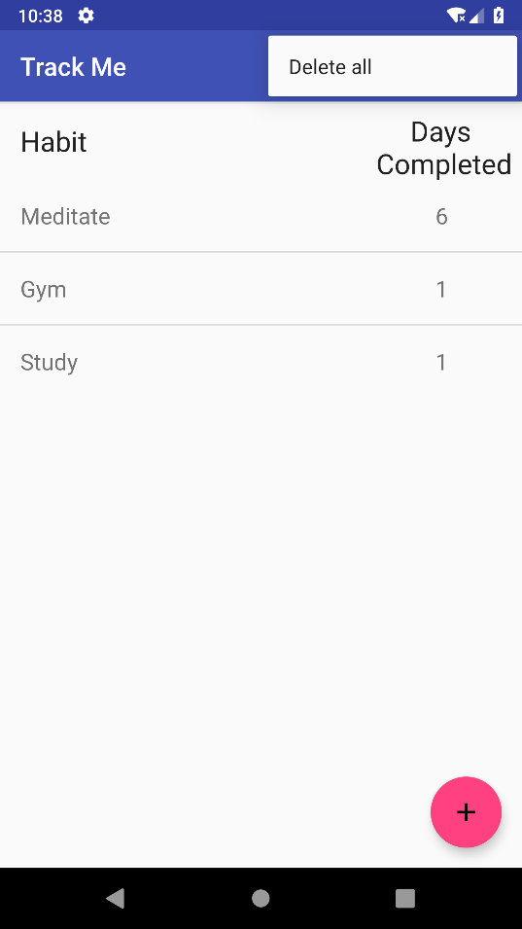

Toast Notification

